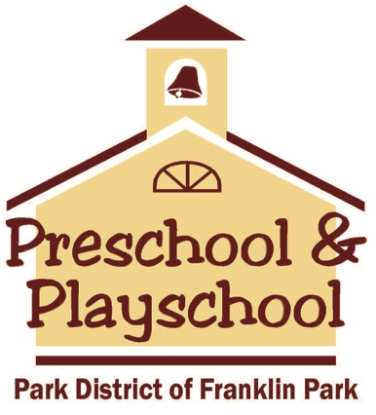
Preschool and Playschool Supply List
2018-2019
____ 1 can of Lysol spray
____ 1 bottle of Greenworks cleaning solution
____ 2 rolls of paper towels
____ 2 boxes of baby wipes
____ 1 box of tissues
____ 1 box of crayons, 24 pack
____ 1 pack of Elmer’s glue sticks
____ 1 pack of playdough, 4 count
____ 1 folder with 2 pockets
____ 1 spiral notebook, 70 pages
____ 1 large backpack labelled with your child’s name
____ 1 change of clothes to be kept in your child’s backpack in case of accidents or spills. Please include a shirt, pants, socks, and underwear.

