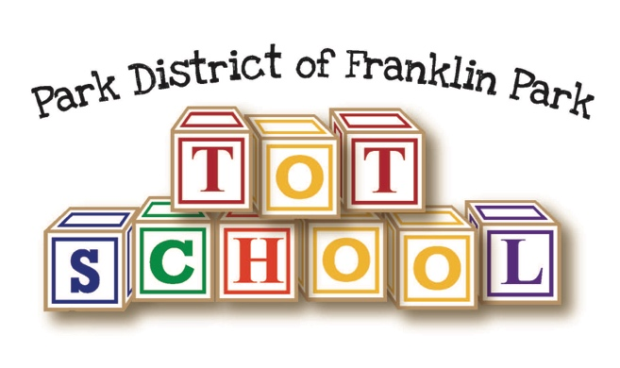
Tot School Supply List
2018-2019
____ 1 can of Lysol spray
____ 2 rolls of paper towels
____ 1 box of tissues
____ 1 pack of Elmer’s glue sticks
____ 1 box of crayons, 24 count
____ 1 large backpack, labelled with your child’s name
____ 1 change of clothes to be kept in your child’s backpack at school in case of accidents or spills. Please include a shirt, pants, socks, and underwear.

